Exercise 1
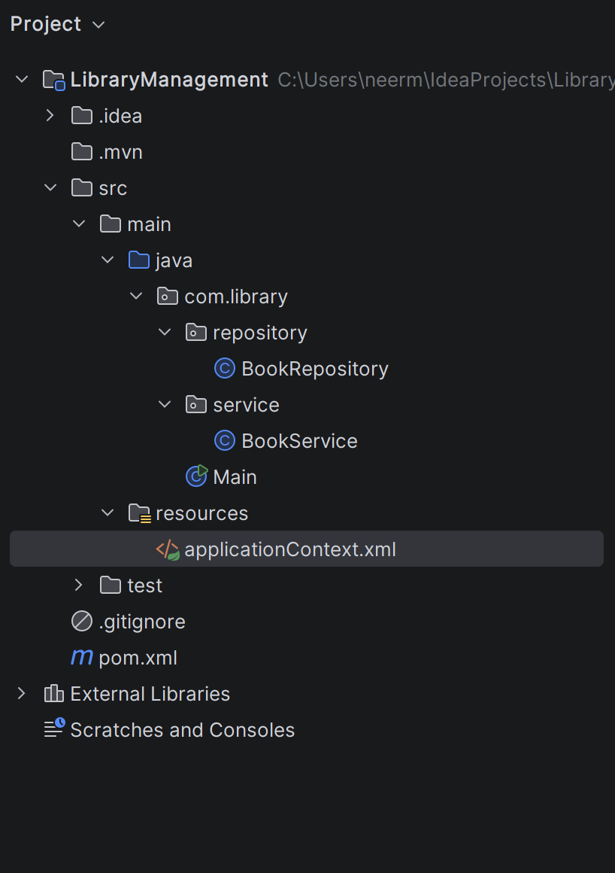

applicationContext.xml
<?xml version="1.0" encoding="UTF-8"?>
<beans xmlns="http://www.springframework.org/schema/beans"
xmlns:xsi="http://www.w3.org/2001/XMLSchema-instance"
xsi:schemaLocation="
http://www.springframework.org/schema/beans
https://www.springframework.org/schema/beans/spring-beans.xsd">
<bean id="bookRepository"
class="com.library.repository.BookRepository"/>
<bean id="bookService"
class="com.library.service.BookService"/>
</beans>

pom.xml
<?xml version="1.0" encoding="UTF-8"?>
<project xmlns="http://maven.apache.org/POM/4.0.0"
xmlns:xsi="http://www.w3.org/2001/XMLSchema-instance"
xsi:schemaLocation="http://maven.apache.org/POM/4.0.0 http://maven.apache.org/xsd/maven-4.0.0.xsd">
<modelVersion>4.0.0</modelVersion>
<groupId>com.library</groupId>
<artifactId>LibraryManagement</artifactId>
<version>1.0-SNAPSHOT</version>
<properties>
<maven.compiler.source>21</maven.compiler.source>
<maven.compiler.target>21</maven.compiler.target>
<project.build.sourceEncoding>UTF-8</project.build.sourceEncoding>
</properties>
<dependencies>
<dependency>
<groupId>org.springframework</groupId>
<artifactId>spring-context</artifactId>
<version>6.2.7</version>
</dependency>
</dependencies>
</project>

Exercise 2
Main.java
package com.library;
import com.library.service.BookService;
import org.springframework.context.ApplicationContext;
import org.springframework.context.support.ClassPathXmlApplicationContext;
public class Main {
public static void main(String[] args) {
ApplicationContext context =
new ClassPathXmlApplicationContext("applicationContext.xml");
BookService service =
context.getBean("bookService", BookService.class);
service.display();
}
}

BookRepository.java
package com.library.repository;
public class BookRepository {
public void display() {
System.out.println("Book Repository Called");
}
}

BookService.java
package com.library.service;
import com.library.repository.BookRepository;
public class BookService {
private BookRepository bookRepository;
public void setBookRepository(BookRepository bookRepository) {
this.bookRepository = bookRepository;
}
public void display() {
System.out.println("Book Service Called");
bookRepository.display();
}
}

applicationContext.xml
<?xml version="1.0" encoding="UTF-8"?>
<beans xmlns="http://www.springframework.org/schema/beans"
xmlns:xsi="http://www.w3.org/2001/XMLSchema-instance"
xsi:schemaLocation="
http://www.springframework.org/schema/beans
https://www.springframework.org/schema/beans/spring-beans.xsd">
<bean id="bookRepository"
class="com.library.repository.BookRepository"/>
<bean id="bookService"
class="com.library.service.BookService">
<property name="bookRepository"
ref="bookRepository"/>
</bean>
</beans>

Output
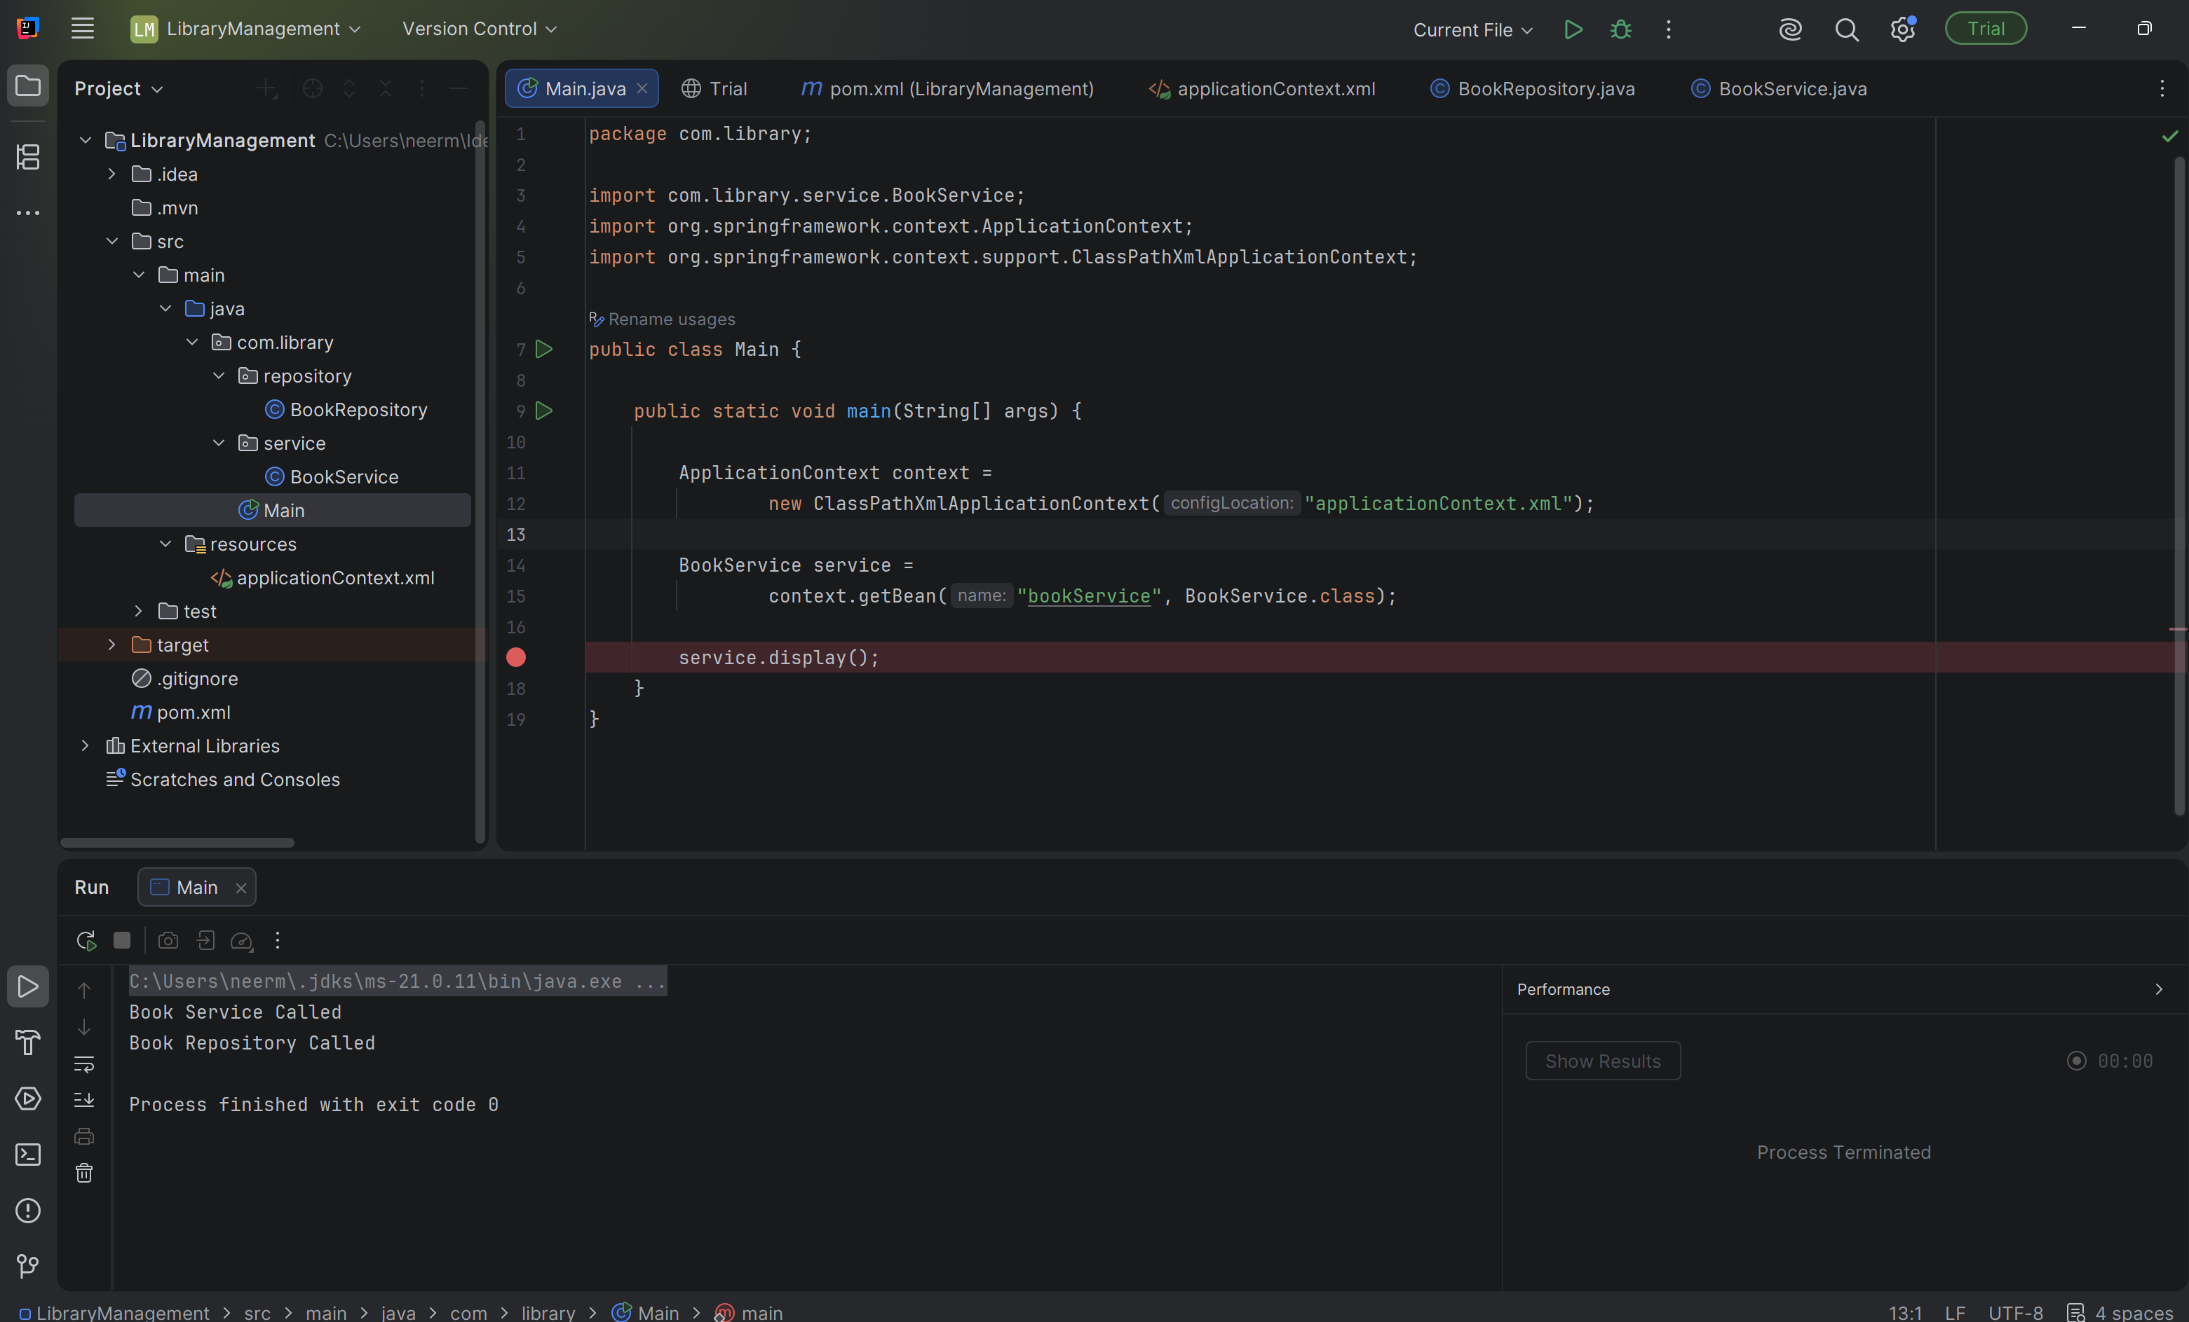

Exercise 3
pom.xml
<?xml version="1.0" encoding="UTF-8"?>
<project xmlns="http://maven.apache.org/POM/4.0.0"
xmlns:xsi="http://www.w3.org/2001/XMLSchema-instance"
xsi:schemaLocation="http://maven.apache.org/POM/4.0.0 http://maven.apache.org/xsd/maven-4.0.0.xsd">
<modelVersion>4.0.0</modelVersion>
<groupId>com.library</groupId>
<artifactId>LibraryManagement</artifactId>
<version>1.0-SNAPSHOT</version>
<properties>
<maven.compiler.source>21</maven.compiler.source>
<maven.compiler.target>21</maven.compiler.target>
<project.build.sourceEncoding>UTF-8</project.build.sourceEncoding>
</properties>
<dependencies>
<dependency>
<groupId>org.springframework</groupId>
<artifactId>spring-context</artifactId>
<version>6.2.7</version>
</dependency>
<dependency>
<groupId>org.springframework</groupId>
<artifactId>spring-aop</artifactId>
<version>6.2.7</version>
</dependency>
<dependency>
<groupId>org.aspectj</groupId>
<artifactId>aspectjweaver</artifactId>
<version>1.9.24</version>
</dependency>
</dependencies>
</project>

LogginAspect.java
package com.library.aspect;
import org.aspectj.lang.ProceedingJoinPoint;
import org.aspectj.lang.annotation.*;
import org.springframework.stereotype.Component;
@Aspect
@Component
public class LoggingAspect {
@Around("execution(* com.library.service.*.*(..))")
public Object logExecutionTime(ProceedingJoinPoint joinPoint) throws Throwable {
long start = System.currentTimeMillis();
Object result = joinPoint.proceed();
long end = System.currentTimeMillis();
System.out.println(joinPoint.getSignature().getName()
+ " executed in "
+ (end - start)
+ " ms");
return result;
}
}

applicationContext.xml
<?xml version="1.0" encoding="UTF-8"?>
<beans xmlns="http://www.springframework.org/schema/beans"
xmlns:xsi="http://www.w3.org/2001/XMLSchema-instance"
xmlns:aop="http://www.springframework.org/schema/aop"
xsi:schemaLocation="
http://www.springframework.org/schema/beans
https://www.springframework.org/schema/beans/spring-beans.xsd
http://www.springframework.org/schema/aop
https://www.springframework.org/schema/aop/spring-aop.xsd">
<bean id="bookRepository"
class="com.library.repository.BookRepository"/>
<bean id="bookService"
class="com.library.service.BookService">
<property name="bookRepository"
ref="bookRepository"/>
</bean>
<bean id="loggingAspect"
class="com.library.aspect.LoggingAspect"/>
<aop:aspectj-autoproxy/>
</beans>

Output
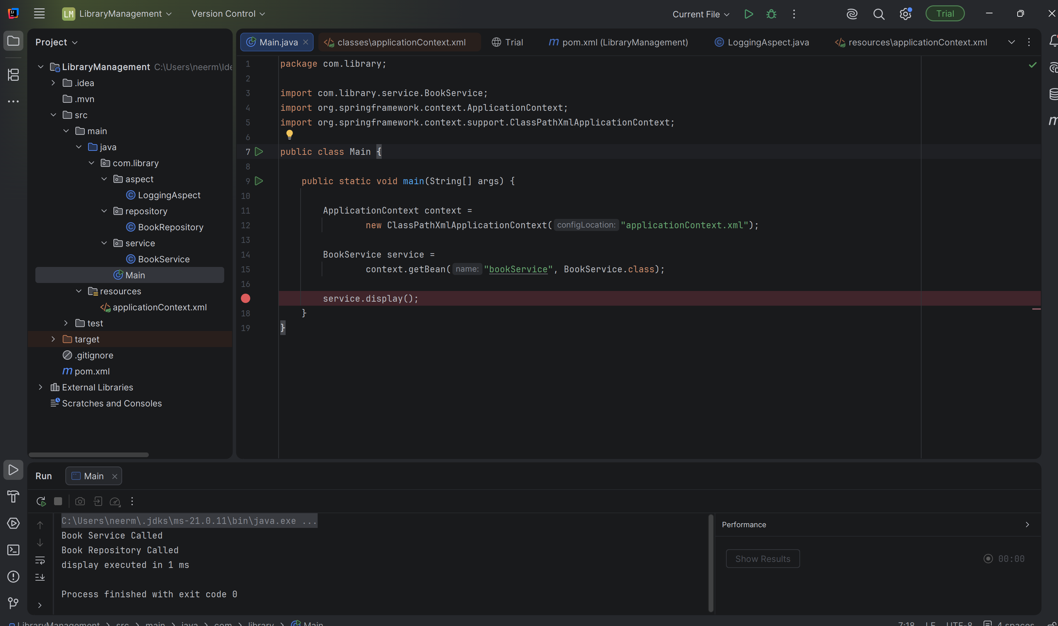

Exercise 4
pom.xml
<?xml version="1.0" encoding="UTF-8"?>
<project xmlns="http://maven.apache.org/POM/4.0.0"
xmlns:xsi="http://www.w3.org/2001/XMLSchema-instance"
xsi:schemaLocation="http://maven.apache.org/POM/4.0.0
http://maven.apache.org/xsd/maven-4.0.0.xsd">
<modelVersion>4.0.0</modelVersion>
<groupId>com.library</groupId>
<artifactId>LibraryManagement</artifactId>
<version>1.0-SNAPSHOT</version>
<packaging>jar</packaging>
<properties>
<project.build.sourceEncoding>UTF-8</project.build.sourceEncoding>
<maven.compiler.source>1.8</maven.compiler.source>
<maven.compiler.target>1.8</maven.compiler.target>
</properties>
<dependencies>
<dependency>
<groupId>org.springframework</groupId>
<artifactId>spring-context</artifactId>
<version>5.3.39</version>
</dependency>
<dependency>
<groupId>org.springframework</groupId>
<artifactId>spring-aop</artifactId>
<version>5.3.39</version>
</dependency>
<dependency>
<groupId>org.aspectj</groupId>
<artifactId>aspectjweaver</artifactId>
<version>1.9.22</version>
</dependency>
<dependency>
<groupId>org.springframework</groupId>
<artifactId>spring-webmvc</artifactId>
<version>5.3.39</version>
</dependency>
</dependencies>
<build>
<plugins>
<plugin>
<groupId>org.apache.maven.plugins</groupId>
<artifactId>maven-compiler-plugin</artifactId>
<version>3.11.0</version>
<configuration>
<source>1.8</source>
<target>1.8</target>
</configuration>
</plugin>
</plugins>
</build>
</project>

Exercise 5

applicationContext.xml
<?xml version="1.0" encoding="UTF-8"?>
<beans xmlns="http://www.springframework.org/schema/beans"
xmlns:xsi="http://www.w3.org/2001/XMLSchema-instance"
xsi:schemaLocation="
http://www.springframework.org/schema/beans
https://www.springframework.org/schema/beans/spring-beans.xsd">
<bean id="bookRepository"
class="com.library.repository.BookRepository"/>
<bean id="bookService"
class="com.library.service.BookService">
<property name="bookRepository"
ref="bookRepository"/>
</bean>
</beans>

BookRepository.java
package com.library.repository;
public class BookRepository {
public void displayBook() {
System.out.println("Book Repository: Book details fetched successfully.");
}
}

BookService.java

package com.library.service;
import com.library.repository.BookRepository;
public class BookService {
private BookRepository bookRepository;
public void setBookRepository(BookRepository bookRepository) {
this.bookRepository = bookRepository;
}
public void displayBookService() {
System.out.println("Book Service: Processing request...");
bookRepository.displayBook();
}
}

Main.java

package com.library;
import com.library.service.BookService;
import org.springframework.context.ApplicationContext;
import org.springframework.context.support.ClassPathXmlApplicationContext;
public class Main {
public static void main(String[] args) {
ApplicationContext context =
new ClassPathXmlApplicationContext("applicationContext.xml");
BookService service =
context.getBean("bookService", BookService.class);
service.displayBookService();
}
}

Output
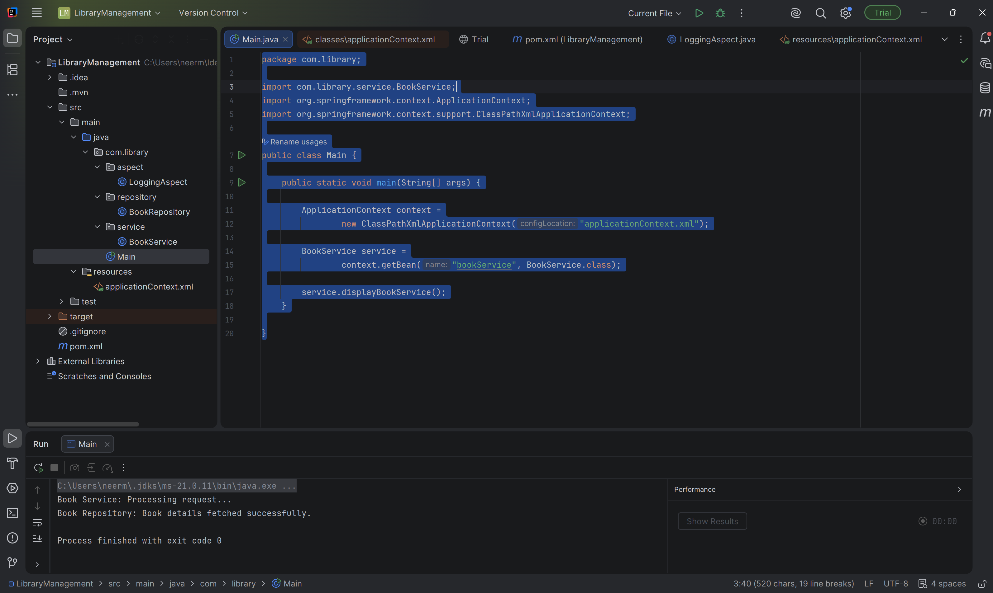

Exercise 6

applicationContext.xml
<?xml version="1.0" encoding="UTF-8"?>
<beans xmlns="http://www.springframework.org/schema/beans"
xmlns:xsi="http://www.w3.org/2001/XMLSchema-instance"
xmlns:context="http://www.springframework.org/schema/context"
xsi:schemaLocation="
http://www.springframework.org/schema/beans
https://www.springframework.org/schema/beans/spring-beans.xsd
http://www.springframework.org/schema/context
https://www.springframework.org/schema/context/spring-context.xsd">
<context:component-scan base-package="com.library"/>
</beans>

BookRepository.java
package com.library.repository;
import org.springframework.stereotype.Repository;
@Repository
public class BookRepository {
public void displayBook() {
System.out.println("Book Repository: Book details fetched successfully.");
}
}

BookService.java
package com.library.repository;
import org.springframework.stereotype.Repository;
@Repository
public class BookRepository {
public void displayBook() {
System.out.println("Book Repository: Book details fetched successfully.");
}
}

Main.java
package com.library;
import com.library.service.BookService;
import org.springframework.context.ApplicationContext;
import org.springframework.context.support.ClassPathXmlApplicationContext;
public class Main {
public static void main(String[] args) {
ApplicationContext context =
new ClassPathXmlApplicationContext("applicationContext.xml");
BookService service =
context.getBean(BookService.class);
service.displayBookService();
}
}

Output
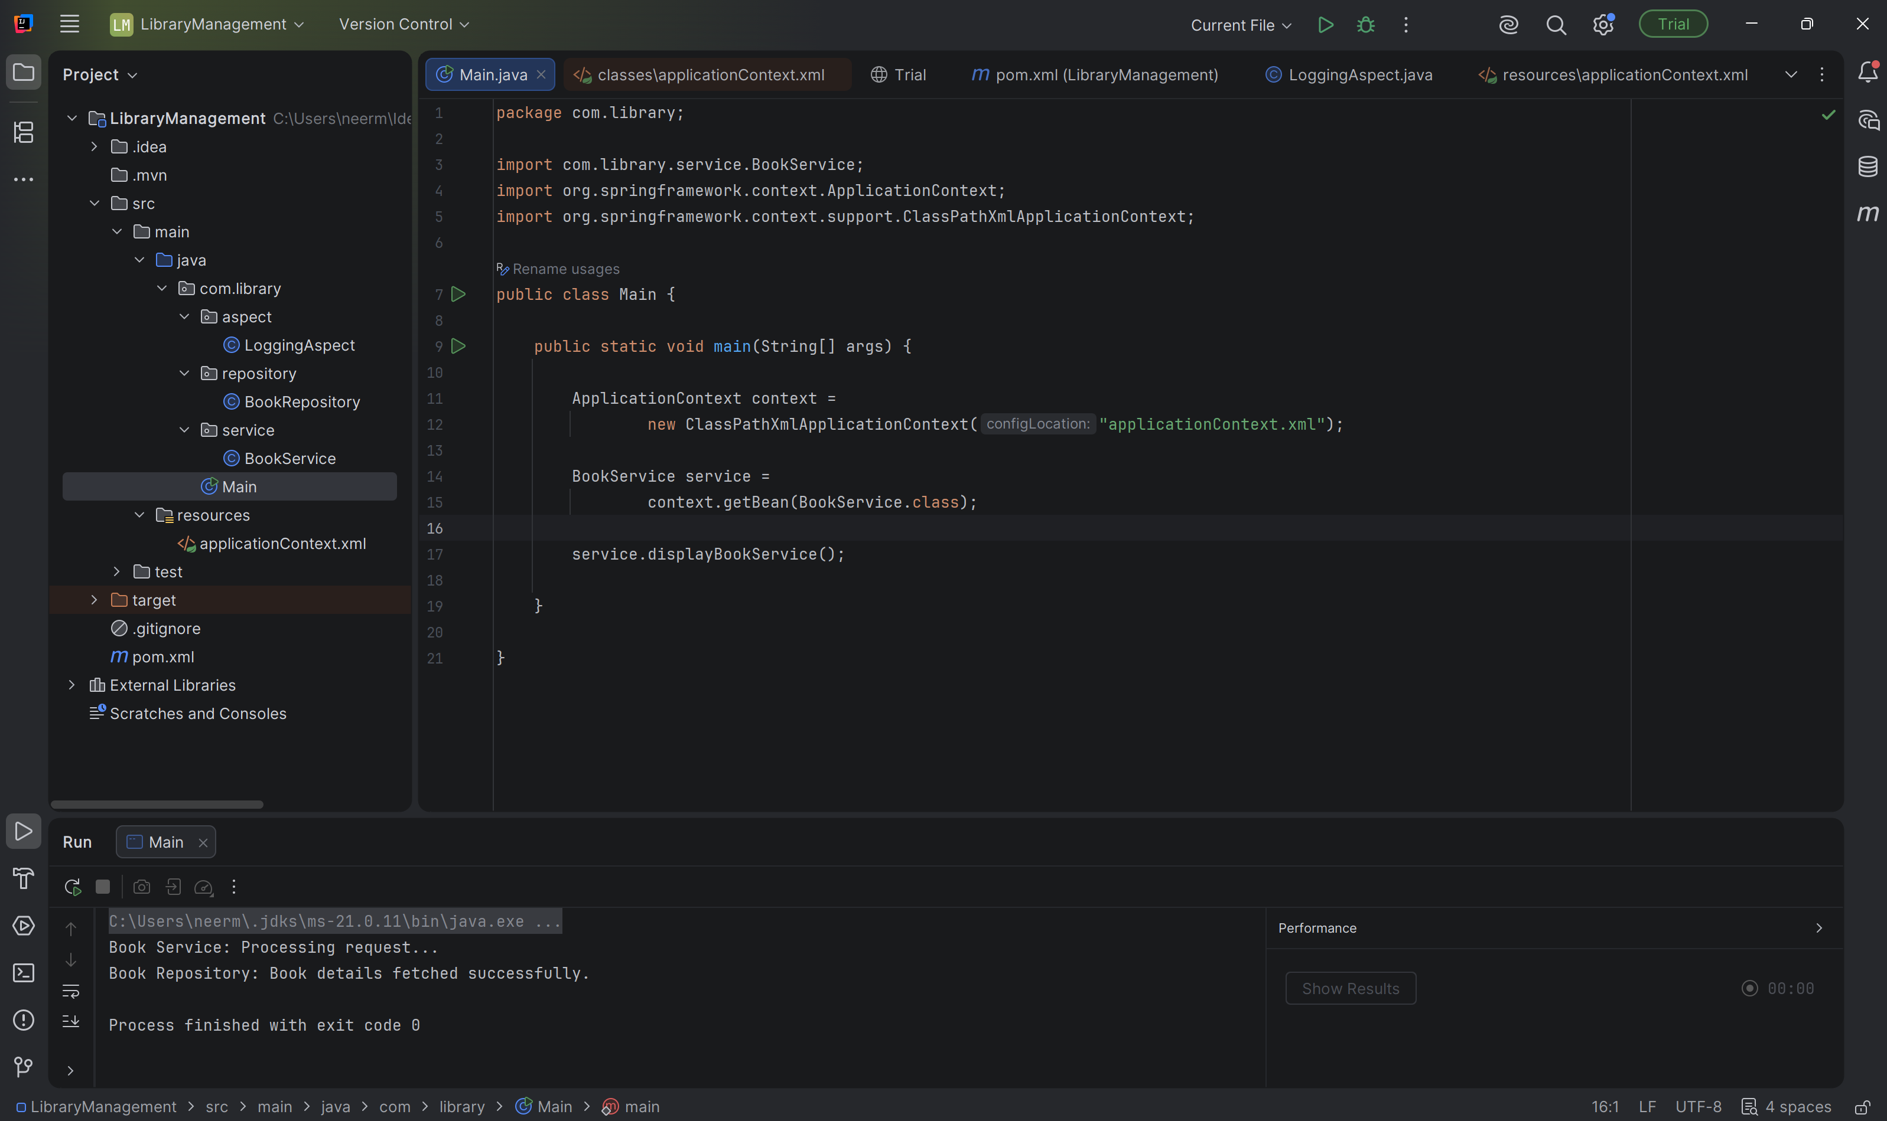
Exercise 7

applicationContext.xml
<?xml version="1.0" encoding="UTF-8"?>
<beans xmlns="http://www.springframework.org/schema/beans"
xmlns:xsi="http://www.w3.org/2001/XMLSchema-instance"
xsi:schemaLocation="
http://www.springframework.org/schema/beans
https://www.springframework.org/schema/beans/spring-beans.xsd">
<bean id="bookRepository"
class="com.library.repository.BookRepository"/>
<bean id="bookService"
class="com.library.service.BookService">
<constructor-arg value="Central Library"/>
<property name="bookRepository"
ref="bookRepository"/>
</bean>
</beans>

BookRepository.java
package com.library.repository;
public class BookRepository {
public void displayBook() {
System.out.println("Book Repository: Book details fetched successfully.");
}
}

BookService.java
package com.library.service;
import com.library.repository.BookRepository;
public class BookService {
private String libraryName;
private BookRepository bookRepository;
public BookService(String libraryName) {
this.libraryName = libraryName;
}
public void setBookRepository(BookRepository bookRepository) {
this.bookRepository = bookRepository;
}
public void displayBookService() {
System.out.println("Library Name: " + libraryName);
System.out.println("Book Service: Processing request...");
bookRepository.displayBook();
}
}

Main.java
package com.library;
import com.library.service.BookService;
import org.springframework.context.ApplicationContext;
import org.springframework.context.support.ClassPathXmlApplicationContext;
public class Main {
public static void main(String[] args) {
ApplicationContext context =
new ClassPathXmlApplicationContext("applicationContext.xml");
BookService service =
context.getBean("bookService", BookService.class);
service.displayBookService();
}
}

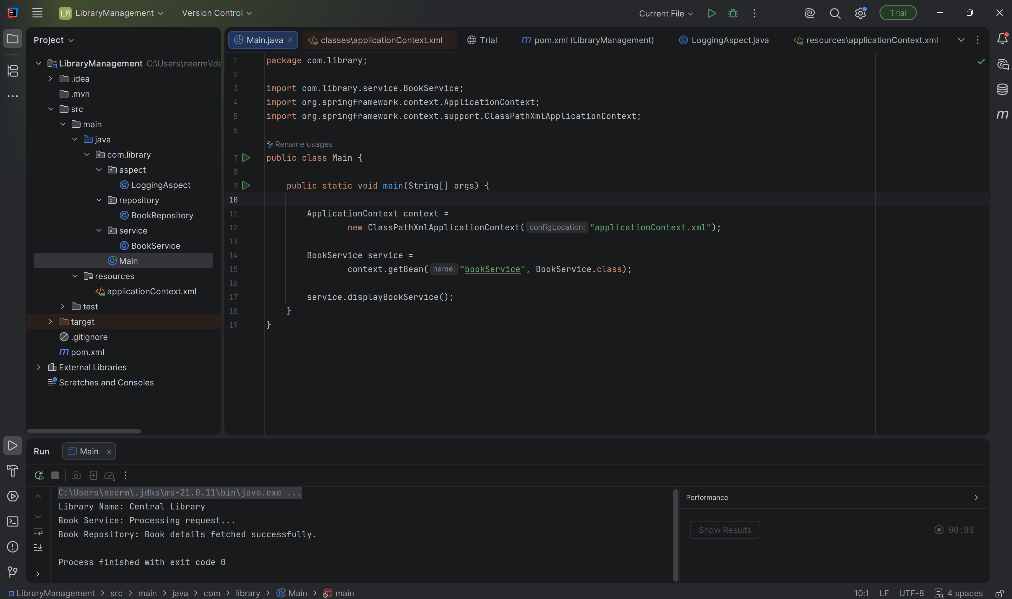
Exercise 8
applicationContext.xml
<?xml version="1.0" encoding="UTF-8"?>
<beans xmlns="http://www.springframework.org/schema/beans"
xmlns:xsi="http://www.w3.org/2001/XMLSchema-instance"
xmlns:aop="http://www.springframework.org/schema/aop"
xsi:schemaLocation="
http://www.springframework.org/schema/beans
https://www.springframework.org/schema/beans/spring-beans.xsd
http://www.springframework.org/schema/aop
https://www.springframework.org/schema/aop/spring-aop.xsd">
<bean id="bookRepository"
class="com.library.repository.BookRepository"/>
<bean id="bookService"
class="com.library.service.BookService">
<property name="bookRepository"
ref="bookRepository"/>
</bean>
<bean id="loggingAspect"
class="com.library.aspect.LoggingAspect"/>
<aop:aspectj-autoproxy/>
</beans>

LoogingAspect.java
package com.library.aspect;
import org.aspectj.lang.JoinPoint;
import org.aspectj.lang.annotation.*;
import org.springframework.stereotype.Component;
@Aspect
@Component
public class LoggingAspect {
@Before("execution(* com.library.service.*.*(..))")
public void beforeMethod(JoinPoint joinPoint) {
System.out.println("Before executing: " + joinPoint.getSignature().getName());
}
@After("execution(* com.library.service.*.*(..))")
public void afterMethod(JoinPoint joinPoint) {
System.out.println("After executing: " + joinPoint.getSignature().getName());
}
}

BookRepository.java
package com.library.repository;
public class BookRepository {
public void displayBook() {
System.out.println("Book Repository: Book details fetched successfully.");
}
}

BookService.java
package com.library.service;
import com.library.repository.BookRepository;
public class BookService {
private BookRepository bookRepository;
public void setBookRepository(BookRepository bookRepository) {
this.bookRepository = bookRepository;
}
public void displayBookService() {
System.out.println("Book Service: Processing request...");
bookRepository.displayBook();
}
}

Main.java
package com.library;
import com.library.service.BookService;
import org.springframework.context.ApplicationContext;
import org.springframework.context.support.ClassPathXmlApplicationContext;
public class Main {
public static void main(String[] args) {
ApplicationContext context =
new ClassPathXmlApplicationContext("applicationContext.xml");
BookService service =
context.getBean("bookService", BookService.class);
service.displayBookService();
}
}

Output
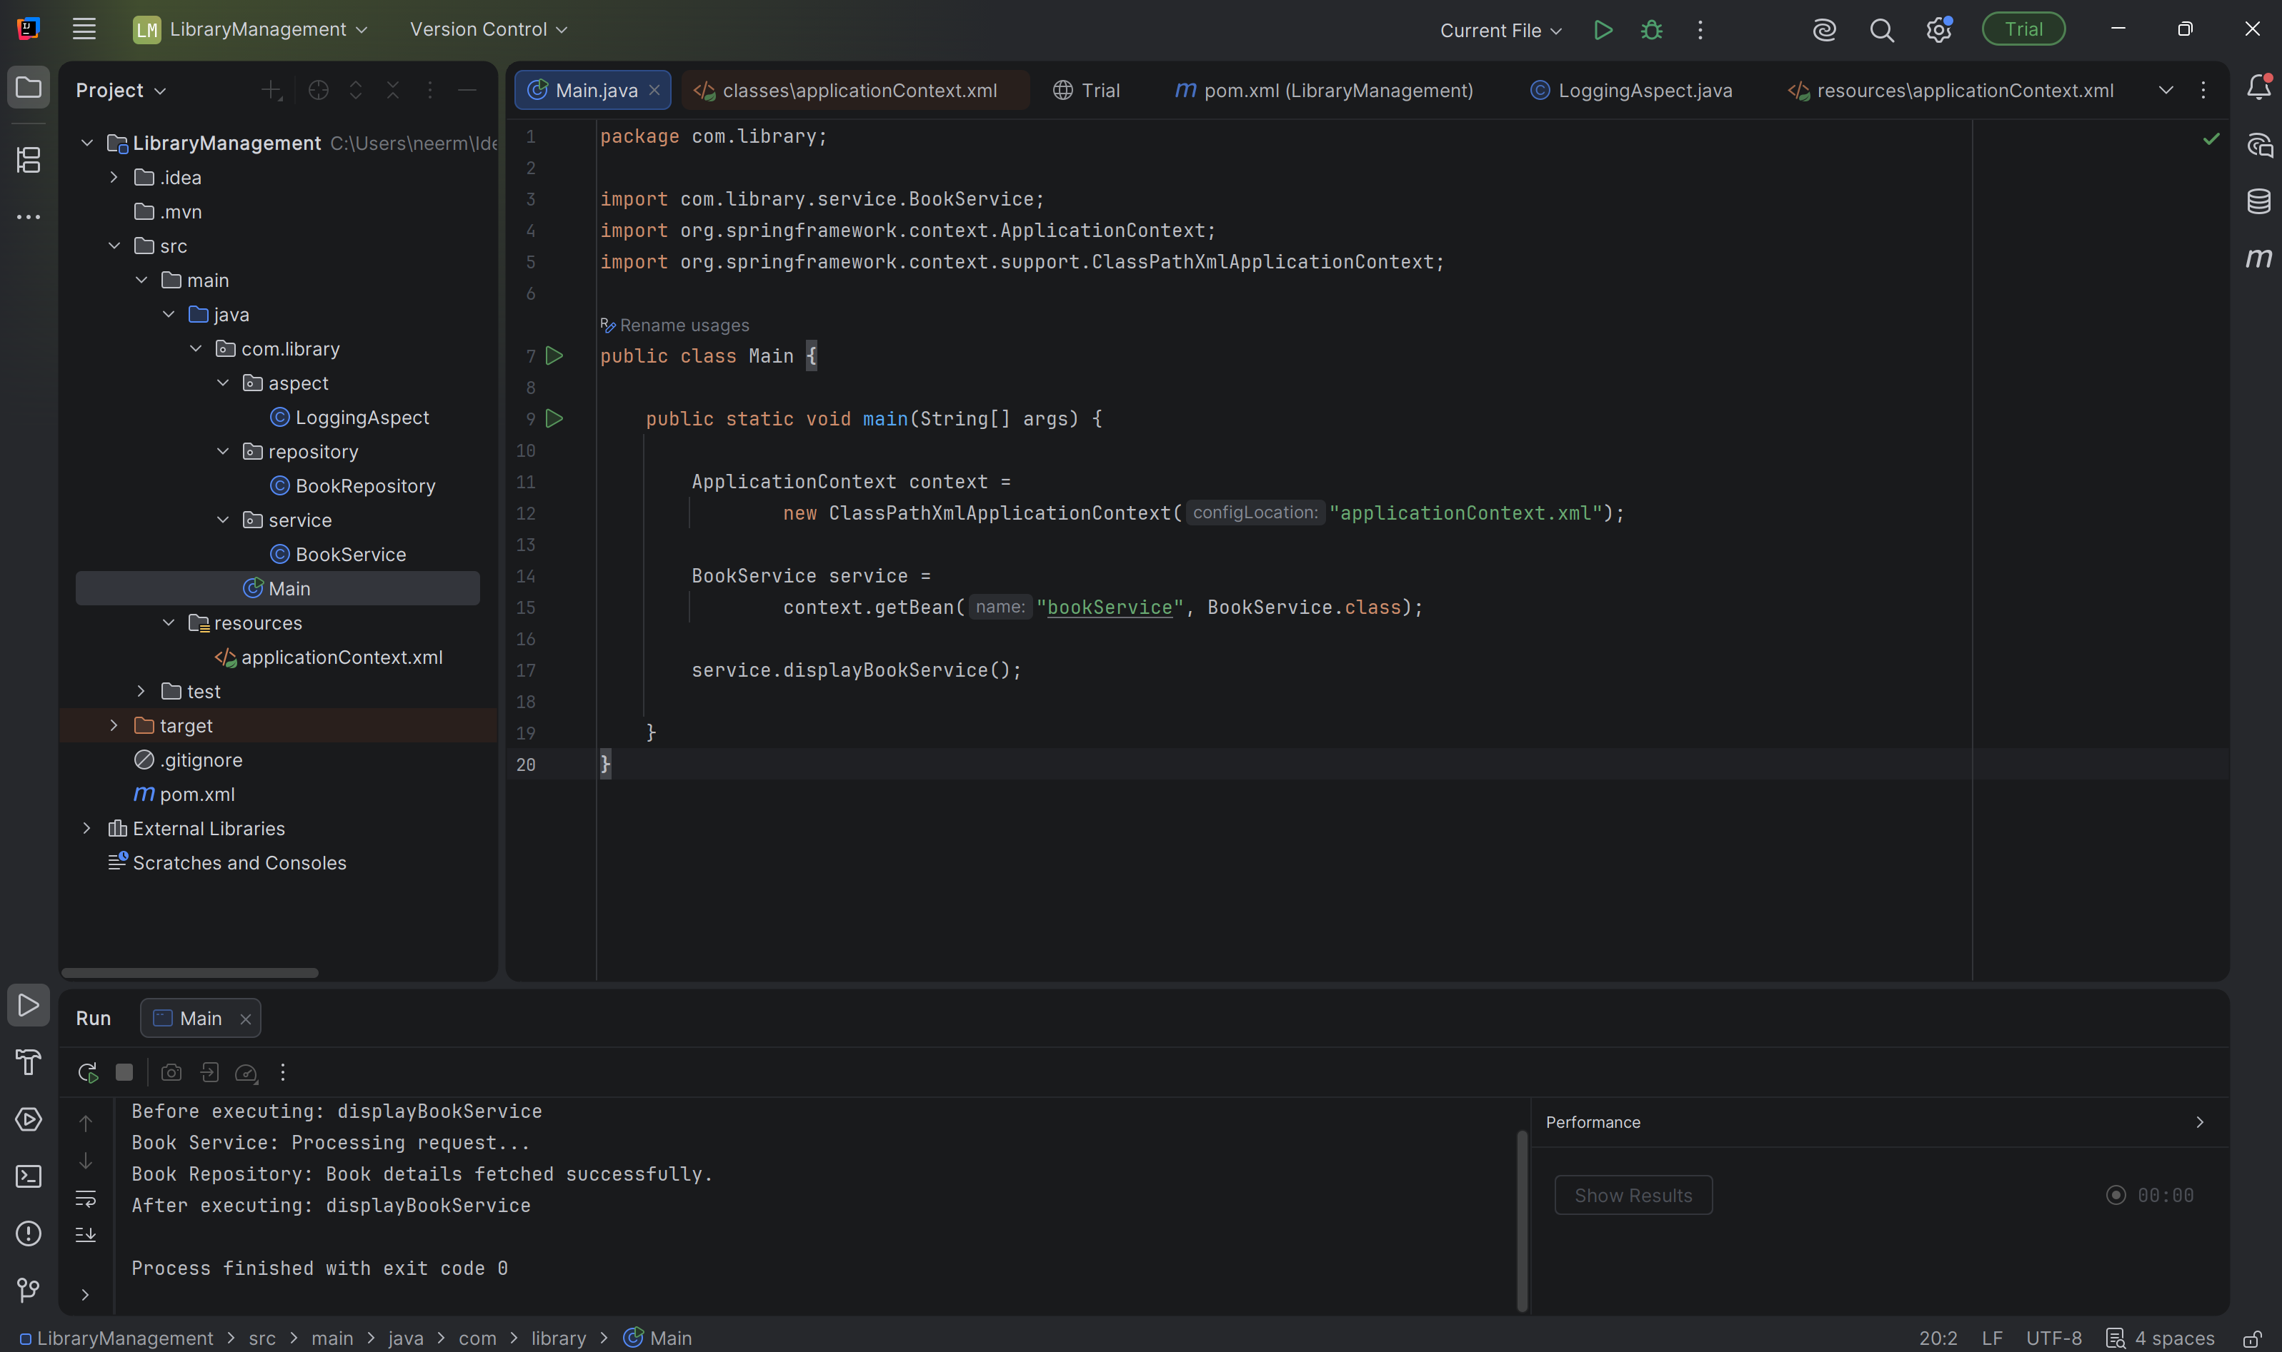

Exercise 9
application.properties
spring.datasource.url=jdbc:h2:mem:librarydb
spring.datasource.driverClassName=org.h2.Driver
spring.datasource.username=sa
spring.datasource.password=
spring.jpa.hibernate.ddl-auto=update
spring.jpa.show-sql=true
spring.h2.console.enabled=true

Book.java
package com.library.entity;
import jakarta.persistence.Entity;
import jakarta.persistence.GeneratedValue;
import jakarta.persistence.GenerationType;
import jakarta.persistence.Id;
@Entity
public class Book {
@Id
@GeneratedValue(strategy = GenerationType.IDENTITY)
private Long id;
private String title;
private String author;
public Book() {
}
public Book(Long id, String title, String author) {
this.id = id;
this.title = title;
this.author = author;
}
public Long getId() {
return id;
}
public void setId(Long id) {
this.id = id;
}
public String getTitle() {
return title;
}
public void setTitle(String title) {
this.title = title;
}
public String getAuthor() {
return author;
}
public void setAuthor(String author) {
this.author = author;
}
}

BookController.java
package com.library.controller;
import com.library.entity.Book;
import com.library.repository.BookRepository;
import org.springframework.web.bind.annotation.*;
import java.util.List;
@RestController
@RequestMapping("/books")
public class BookController {
private final BookRepository repository;
public BookController(BookRepository repository) {
this.repository = repository;
}
@PostMapping
public Book addBook(@RequestBody Book book) {
return repository.save(book);
}
@GetMapping
public List<Book> getBooks() {
return repository.findAll();
}
}

LibraryManagementBootApplication.java
package com.library;
import org.springframework.boot.SpringApplication;
import org.springframework.boot.autoconfigure.SpringBootApplication;
@SpringBootApplication
public class LibraryManagementApplication {
public static void main(String[] args) {
SpringApplication.run(LibraryManagementApplication.class, args);
}
}
